/* Insert sample data in Store_Front tables by using SQL files. */

command used :
mysql > SOURCE File_path\File_name.sql

mysql> SOURCE C:\Users\User17\Desktop\inputFile.sql

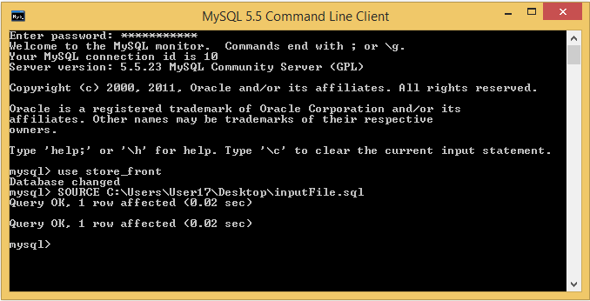

Contents of file:
INSERT INTO users(first_name, last_name, email, password, phone, type)
VALUES ("rahul", "sharma", "rahulsharma@gmail.com", "rahul123", "8504846657", "shopper");

INSERT INTO address(house_no, street, landmark, city, state, pincode, user_id)
VALUES (161, "sms stadium", "india gate", "jaipur", "rajasthan", "302022", 6);

